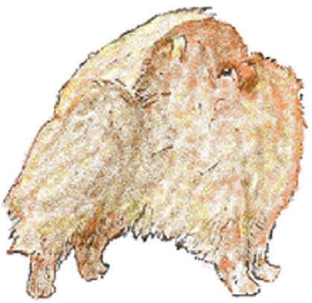
The Pomeranian Club
Founded 1891

 | Patron: Mrs S Sharratt
President: The Late Mrs B Flavell
Chairperson: Mr S Gwynne  Secretary: Mrs J Pike | Treasurer: Mrs A Cawthera-Purdy  Springfield  Gotherington Fields  Nr Cheltenham  Gloscestershire  GL52 9SB  Tel: 01242 672044
 | thepomeranianclub@hotmail.co.uk

Application for New Membership
(please complete in BLOCK CAPITALS)
Name:....................................................................................................
Address:.................................................................................................
Tel:................................................ | Email:............................................
Kennel Name:...........................................................................................
Proposed by:..................................... | Kennel Name:...................................
Address:..................................................................................................
Seconded by:..................................... | Kennel Name:...................................
Address:..................................................................................................
Include membership badge Yes No If yes, please include £6 extra for 1 badge

Both proposer AND seconder MUST be paid up members

Membership is from November 1st until October 31st and all renewals MUST be paid by September 30th of that year to retain valid membership. New applications made at the October show, if accepted, will be valid until October 31st of the following year.

Please return this application to the Treasurer with the correct subscription - £7.00 joint membership and £5.00 single membership along with £6 extra if including The Pomeranian Club membership badge. Your membership application will be presented to the committee of The Pomeranian Club at the next meeting.

To access information regarding how your data will be used please visit The Pomeranian Club website https://thepomeranianclubuk.weebly.com/gdpr-privacy-notice.html

