EXHIBITORS PLEASE NOTE:
Information regarding the venue:
The Weston Hall Hotel

The Weston Hall Hotel prides itself on being ‘doggy friendly’, please ensure that you and your dogs do not give cause to change this. Please do not groom, trim or use talc in your bedroom. The Hotel are happy for your dog(s) to be in your room, however, there will be an additional cleaning charge of £10 per room if you take up this option. You may be told £10 per dog as this is hotel policy, however a special rate of £10 per room has been arranged by the Club and your bill will adjusted to this.

Directions to the Venue:
Go to Junction 2 of the M6. At the roundabout take the first left signposted Ansty / Shilton. At traffic lights in Shilton turn left for Bulkington. On reaching B4029 turn left. At the end of the village, turn left down Weston Lane (signposted) Weston Hall on right hand side of road). Proceed to mini roundabout and take last exit. You are in the car park of the Weston Hotel. The venue is round to the left of the hotel and has its own dedicated car park outside the main entrance to the conference centre. As there are steps up from here to the main area from dogs and grooming we have permission for heavier trolleys, wheeled tables etc to be taken carefully through the hotel to avoid lifting.

Staying at the Hotel:
The Pomeranian Club has negotiated the following rates with the Weston Hall Hotel for those wishing to stay.
Bed/Breakfast:
1 night: Double or Twin - £70 Single - £65
2 nights: Double or Twin - £65 Single - £55

Please also note that the Hotel will refer any rooms left in a poor condition to the Committee and will also charge the occupant for any extra cleaning costs etc incurred. In extreme cases the Committee will consider both reporting any misuse to the Kennel Club and consequently could invoke the Club’s right to refuse future entries from those concerned.

When booking accommodation please ask for the Conference and Banqueting Manager. You need to mention that you are attending The Pomeranian Club Championship Show when booking to get the above rates.

The telephone number is: 02476 312989

*** Refreshments if purchased in The Manor Suite ***
Beverages: £1.50 per cup
Sandwiches from: £3.25
President: Mrs B Flavell Founded 1891 Patron: Mrs S Sharratt
**********

THE POMERANIAN CLUB

Schedule of a 25 class unbenched single breed
CHAMPIONSHIP SHOW
held under Kennel Club rules & show regulations at
THE WESTON HALL HOTEL, WESTON LANE,
BULKINGTON, Nr COVENTRY CV12 9RU
SUNDAY, 1st APRIL 2018
Only undocked dogs and legally docked dogs may be entered for exhibition at this show.

Show Opens: 9.30am Judging starts: 10.30am
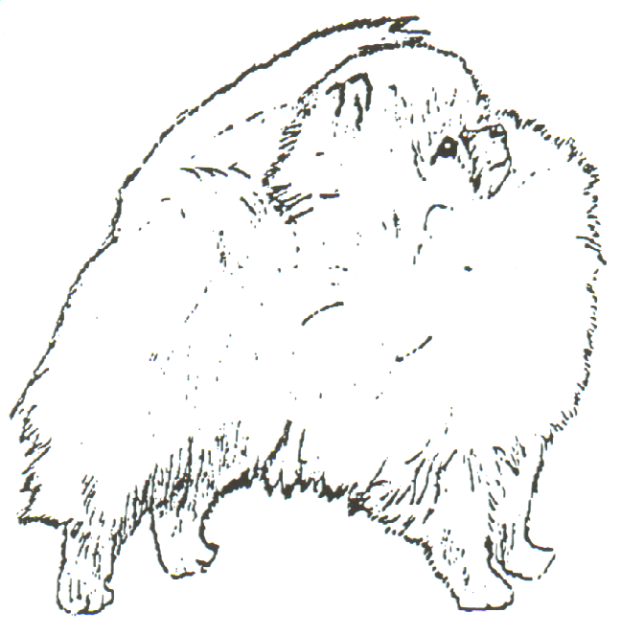
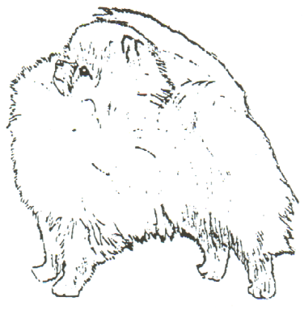

JUDGE: - Miss Vanda Smith (Sidlyn)
All judges at this show agree to abide by the following statement: “In assessing dogs, judges must penalise any features of exaggerations which they consider would be detrimental to the soundness, health and well being of the dog.”

ENTRIES CLOSE: - 15th March 2018 (1st Class Postmark)
Entries to be sent to: - Hon Treas Mrs Averil Cawthera-Pury Springfield, Gotherington Fields, Nr Cheltenham GL52 9SB
Tel: 01242 672044

GUARANTORS TO THE KENNEL CLUB: -

Chairperson. : Mr Sean Gwynne, Springfield, Gotherington Fields, Cheltenham GL52 9SB
Hon Secretary: Mrs Julie Pike, Breezelyn Kennels, Titson, Bude, Cornwall. EX23 0HH
Hon Treas: Mrs. Averil Cawthera-Purdy, Springfield, Gotherington Fields, Cheltenham. GL52 9SB
Mrs Linda Matthews 23 Meadow Lane Warrington Cheshire
Mr Alan Pike Breezelyn Kennels Titson Bude Cornwall EX23 0HH
Miss Ashlie Pike Breezelyn Kennels Titson Bude Cornwall EX23 0HH

Hon. Vet. Surgeons: Paws Veterinary Health Centre, Edward St.,

Nuneaton CV11 5RP Tel: 02476 384064
THE POMERANIAN CLUB
PRESIDENT: Mrs Betty Flavell

PATRON: Mrs Sandra Sharratt

HON VICE PRESIDENTS: Mrs Oriel Rudd-Orthner
Mrs Margaret Watkins
Mr John Clay

CHAIRPERSON: Mr Sean Gwynne

HON SECRETARY: Mrs Julie Pike

HON TREASURER MEMBERSHIP Mrs Averil Cawthera-Purdy
AND SHOW SECRETARY:
COMMITTEE: Mr Alan Pike
` Miss Ashlie Pike Mrs Linda Robinson
Mrs Linda Matthews Mr David Strange
Mrs Fay Matthews-Jones Mrs Heather Yule
Mr Chris Van De Burgt
**There will be a Not For Competition PUPPY WALK held in the Lunch Hour – Puppies must be between 4 & 6mths of age and must be listed as NFC**
Our Judge – Miss Vanda Smith (Sidlyn)
She writes: I have been showing Poms since the 70's (beginning as a junior handler) moving into adulthood I owned and bred some reasonable Poms before joining my Mum in the Sidlyn affix. I learnt how to judge, and what to look for the hard way, starting at the bottom (Exemption shows, Ltd then Open) & had so much help and advice along the way (Bob & Betty Flavell, Lil Weinert, Dot Hay, Ann Winter & Averil Cawthera to name a few). The late Jessie Newman, at the time Secretary of SOE P C, took both Mum and I under her wing and backed us all the way to CC status. I gave my first set of tickets in 1998 and have since given 5 more sets.
We were so lucky in 1992 due to the tragic death of her Husband, to be given Shemond Little Miss Brodie, (the Sidlyn affix was added later) by our very good friend the now late Sheila Park on the understanding that I would campaign her, this I did with much success "Brodie" took BPIS in show in '92 at the PC under Heather Moores, and took her 1st CC again at the PC under Lynn Webster the next 2 quickly followed and Brodie was Top Bitch in Breed in '93 & joint top in '94 Brodie has been singled out because she was such a joy to own and show, she ended her career with 17 CC's and many reserves. We have obviously bred, shown and had success with many others.
I am very much looking forward to judging for the "Mother" Club which I consider to be a huge honour and thank both the Committee for the invitation and those Members who voted for me.
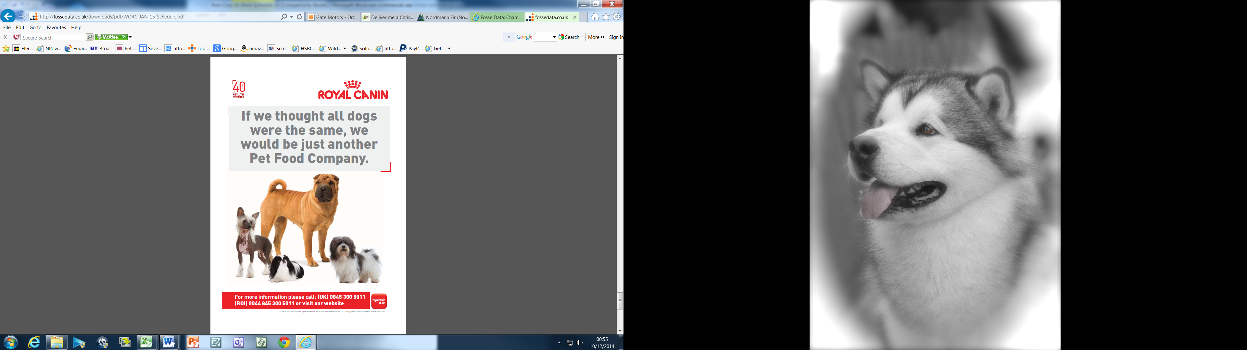

at risk by any action, default, omission or otherwise. Breach of Kennel Club Regulations in this respect may be referred to the General Committee for disciplinary action under KC Rules and Regulations. Right to refuse entries: Exhibitors/competitors are reminded that show societies have the right under KC Regulation to refuse entries.
- Not for competition entries will be accepted. Details of each dog so entered must be recorded on the entry form and must be KC Registered.
- The show will be held under KC Rules and Show Regulations. Every exhibitor making an entry or entries at this show shall be deemed to have agreed to abide by these Rules and Regulations and it is on that understanding that entries are received.
- The Committee at this show cannot be held responsible for products advertised or sold by standholders at the show and remind exhibitors that such products may not meet the requirements of the regulations for the Preparation of Dogs for Exhibition.
- Exhibitors/handlers are responsible for clearing up and removing any loose hair or fouling from dogs in their charge or any other litter whether from the car park, the exercise area or from any other part of the venue.
- Parents/Guardians please note, well behaved children are welcome but those in charge of children will be held fully responsible for their actions and any damage caused within the environs of the show.
- Owners, handlers, exhibitors or any other person in charge of a dog at a KC Licensed event must ensure at all times that the dog is kept under proper control whilst at the licensed venue including its environs, car parks and approaches.
A dog my be disqualified by the General Committee from any award, whether an objection has been lodged or not, if proved amongst other things to have been registered or recorded as having been bred by the scheduled judge. This shall not apply to a judge appointed in an emergency.

Regulations for the Preparation of Dogs for Exhibition F(B)

1. These regulations must be observed when a dog is prepared for exhibition and/or exhibited at any Kennel Club licensed event. Objections may be referred to the General Committee for disciplinary action under these show regulations and/or for disciplinary action under Kennel Club rule A42. a) A dog found to have been exhibited in breach of these regulations will automatically be disqualified from exhibition at the show and from any award gained there at. b) Unless the exhibitor provides a satisfactory explanation for the dog being exhibited in breach of these regulations when he/she may be subject to further penalties of either a fine or as listed under Rule A42.
2.a) No substance which alters the natural colour, texture or body of the coat may be present in the dogs coat for any purpose at any time during the show. No substance which alters the natural colour of any external part of the dog may be present on the dog for any purpose at any time during the show. b) Any other substance other than water which may be used for preparation of a dog for exhibition must not be allowed to remain in the coat or on any other part of the dog at the time of exhibition.
3. No act or operation which alters the natural conformation of a dog or any part thereof except a) Operations certified to the satisfaction of the General Committee. b) The removal of dew claws of any breed. c) Operations to prevent breeding providing that such operations are notified to the Kennel Club before neutered dogs are shown. Nor must anything be done calculated in the opinion of the General Committee to deceive.
4. The General Committee without previous notice may order an examination of any dog or dogs at any show. Any examination thus ordered will be made by a person having executive authority who shall have a written directive from the Kennel Club in their possession. Samples may be taken for further examination and analysis.
5. An individual has the right to lodge an objection to a dog only if he/she is the owner or handler of a dog competing in the same breed or class. An objection may however, be lodged by an official of the show or by anyone so deputed by the Kennel Club. It will be the responsibility of the individual who lodges the objection or the official (as appropriate), to substantiate the grounds for the objection. The Kennel Club will substantiate the grounds for an objection made on its behalf.
6. Any objections by any individual related to an infringement of these rules must be made in writing to the Show Secretary at his/her office before the close of the show and the individual must produce evidence of identity at the time of lodging the complaint.

Classification & Judging Order

Judge: Miss Vanda Smith (Sidlyn)

Kennel Club Challenge Certificate – Dog

Kennel Club Challenge Certificate – Bitch

1. Minor Puppy Dog (6-9 months)
2. Puppy Dog (6-12 months)
3. Junior Dog (6-18 months)
4. Novice Dog
5. Post Graduate Dog
6. Limit Dog
7. Open Dog
8. Special Beginners Dog

9. Minor Puppy Bitch (6-9 months)
10. Puppy Bitch (6-12 months)
11. Junior Bitch (6-18 months)
12. Novice Bitch
13. Post Graduate Bitch
14. Limit Bitch
15. Open Bitch
16. Special Beginners Bitch

17. Special Open Orange Dog/Bitch
18. Special Open Orange Sable Dog/Bitch
19. Special Open White or Parti-Colour Dog/Bitch
20. Special Open Black or Chocolate Dog/Bitch
21. Special Open Any Other Dog/Bitch
22. Special Open Stud Dog
23. Special Open Brood Bitch
24. Veteran Dog/Bitch
25. Brace

Dog CC followed by Bitch CC
Judging for Best in Show and Best Puppy in Show

Not for competition PUPPY WALK to be held in the Lunch Hour
(Puppies from 4mths and under 6mths of age and entered and listed in the catalogue as NFC, please state PUPPY WALK clearly on your entry form)

Definitions of Classes.

In the following definitions, a Challenge Certificate includes any show award that counts towards the title to Champion under the rules of any governing body recognised by the Kennel Club.
Wins at Championship shows in breed classes where Challenge Certificates are not on offer shall be counted as wins at Open shows.
In the case of a dog owned in partnership and entered in Members’ classes or competing for
Members’ specials, each partner must at the time of entry be a member of the Club.
In estimating the number of awards won, all wins up to and including the seventh day before the
date of closing of entries shall be counted when entering for any class: i.e. 8th March 2018.
Wins in Variety classes do not count for entry in Breed classes but when entering for Variety classes, wins in both Breed and Variety classes must be counted. A first prize does not include a Special Prize
of whatever value.
If an exhibitor reports before the judging of a class or classes that a dog has been entered which is ineligible the exhibitor may choose one of the following options:-
Withdrawal: The dog may be withdrawn from competition subject to the conditions of Regulations
9(j) & 20.

Transfer: -
- If a dog is ineligible for a class or classes as regards its colour, sex, weight or height, the Show Secretary shall transfer tit to the equivalent class for the correct colour, sex, weight, or height, and, in the event of there being no equivalent class, Minor Puppy and Puppy excepted, to the Open
- class for the correct colour, sex, weight or height.
- For an exhibit entered incorrectly in a Minor Puppy class or Puppy class, which is over age but under twelve calendar months of age or eighteen calendar months of age respectively, the Show Secretary shall transfer the exhibit to the Puppy class or the Junior class respectively for the correct colour, sex, weight or height, and in the event of there being no Puppy or Junior Class, and
- For any reason other than the above, the Show Secretary shall transfer it to the Open class for the correct colour, sex, weight or height.
If an exhibit arrives late and misses a class, even if it is the only class in which the dog is entered, the dog may not be transferred to any other class.
*The Kennel Club Authority to Compete number (ATC No.) for dogs resident outside of the UK must be stated or the entry form will be returned.
Minor Puppy. For dogs of six and not exceeding nine calendar months of age on the day of the show.
Puppy. For dogs of six and not exceeding twelve calendar months of age on the day of the show.
Junior. For dogs of six and not exceeding eighteen calendar months of age on her day of the show.
Special Yearling. For dogs of 6 and not exceeding 24 calendar months of age on the first day of the show.
Novice. For dogs which have not won a Challenge Certificate or three or more First Prizes at Open and Championship shows (Minor Puppy, Special Minor Puppy, Puppy and Special Puppy classes excepted, whether restricted or not.)
Post Graduate. For dogs which have not won a Challenge Certificate or five or more First Prizes at Championship shows in Postgraduate, Minor Limit, Mid Limit, Limit and Open classes, whether restricted or not.
Limit. For dogs which have not won three Challenge Certificates under three different judges or seven
or more First Prizes in all at Championship shows in Limit and Open classes, confined to the breed, whether restricted or not, at shows where Challenge Certificates were offered for the breed.
Open. For all dogs of all breeds for which the class is provided and eligible for entry at the show.
Special Beginners. Restricted to owners, handlers and exhibitors who have never won a Challenge Certificate in the breed.
Special Open Colour. As for Open, but restricted to dogs registered as the colour/s stated for the class.
Veteran. For dogs of not less than seven years of age on the day of the show.
Special Open Stud Dog. Dogs to have sired at least 1 litter registered with the Kennel Club.
Special Open Brood Bitch. Bitches to have whelped at least 1 litter registered with the Kennel Club.
Special Members Open Stakes. Entrants to be owned by fully paid up members of the Pomeranian Club. To be judged after BIS etc. BIS, RBIS & BPIS to withdraw if entered in this class.
Advisory Notice – Not for Competition Societies may at their discretion, accept Not for Competition entries. Societies may accept such entries from breeds of dog not included within the title of the Society and at shows held over more than one day, such entries may be accepted on any day from any breed.

Rules & Regulations.
- The Show will open at 9.30am
- Dogs will be received at any time but it is the exhibitor’s responsibility to ensure that exhibits are available for judging when required.
- Judging will commence at 10.30am
- Exhibits may be removed from the Show after their judging has been completed. The show will close half an hour after all judging has been completed.
- The use of cooking stoves in the proximity of the tenting and benching areas is forbidden except as authorised by the Show Management.
- Entry fees: The entry fee for members is £11.00 for first entry for each dog, for non-members £15.00 for first entry for each dog. £3.00 for each subsequent class for members and £4.00 non-members. Dogs entered not for competition: £4.00.
- There is no prize money on offer at this show.
- The Committee reserves to itself the right to refuse entries.
- Puppies under six calendar months of age on the day of the Show are not eligible for exhibition.
- The mating of bitches within the precincts of the Show is forbidden.
- Best Puppy in Show. Where a Best Puppy in Show competition is scheduled the Best Puppy in Show is a puppy which has competed and is unbeaten by any other puppy exhibited at the same show. A puppy is a dog of six and not exceeding twelve calendar months of age on the day of the show. Where the Best in Show is a puppy it will also automatically be Best Puppy in Show respectively. Similarly, if the Reserve Best in Show is a puppy which has only been beaten by an adult dog it will also automatically be Best Puppy in Show respectively. Consequently, selection of Best Puppy in Breed and Best Puppy in Show must follow the selection of Best of Breed and Best in Show respectively. Best Puppy in Show must be selected from puppies which have been judged and which are unbeaten by any other puppy. Proviso. For the purpose of this regulation, dogs beaten in competition for Stud Dog, Brood Bitch, Progeny, Brace and Team or a Special Award confined to one breed will not be considered to be a beaten dog.
- Best in Show. The dog declared Best in Show is a dog which has competed and is unbeaten by any other dog exhibited at the same show. Best in Show must be selected from the exhibits declared Best of Sex provided they are unbeaten winning dogs. Reserve Best in Show must be selected from the Best Opposite Sex and the Reserve Best of Sex to the exhibit declared Best in Show. The dogs declared BIS and RBIS must not compete in any subsequent competition. A dog beaten in competition for BIS may subsequently be exhibited in all competition for which it was previously eligible. Dogs beaten in competition for Stud Dog, Brood Bitch, Progeny, Brace and Team or a Special Award confined to a single breed, will not be considered to be beaten dogs.
- Exhibits will not be admitted to Best in Show competition after a period of ten minutes has elapsed since the announcement that exhibits are required for judging, unless they have been unavoidably delayed by previous judging not being completed on time, and only then with the special permission of the Show Management.
- No modification will be made to this schedule except by permission of the General Committee of the Kennel Club, which will be followed by an advertisement in the Canine Press wherever possible.
- All exhibitors must be familiar with Kennel Club Regulation F (Annex B) Regulations for the Preparation of Dogs for Exhibition.
- All dogs resident outside the U.K. must be issued with a Kennel Club Authority to compete number before entry to the show/event can be made. All overseas entries without an Authority to compete number will be returned to the exhibitor/competitor.
- Dogs in cars on Hot Days. Your dog is vulnerable and at risk during hot weather and the Kennel Club offers the following guidance to help you through the do’s and don’ts travelling to and from and whilst at KC Licensed events: When travelling to a show please take a moment to consider whether the route to the show is on a busy holiday route and leave earlier to avoid increased time in traffic jams; If your vehicle is not air conditioned seriously consider whether travelling to the show is a good idea at all; The vehicle should be as fully ventilated as possible and plenty of stops should be taken with lots of water available to drink; Ensure your dog is not sitting in full sunlight. There should be plenty of free flowing air around the dog; When at the show never leave your dog in the vehicle; Keep the dog in the shade – take your own shade eg a large umbrella and always have plenty of water available to drink so your dog stays well hydrated; Avoid your dog taking part in unnecessary exertion or from standing in exposed sunlight for extended lengths of time. Remember, if you feel hot your dog is likely to feel much hotter and dehydrated. This could lead to dire results. Please look after your dog’s welfare. WARNING: IF YOUR DOG IS FOUND TO BE AT RISK FORCIBLE ENTRY TO YOUR VEHICLE MAY BE NECESSARY WITHOUT LIABILITY FOR ANY DAMAGE CAUSED. Anyone whose dog is entered at a KC Licensed event should take all reasonable steps to ensure the needs of their dog(s) are met and should not put a dog’s health and welfare

